Grade 7 Summer Reading List Mrs. Jenna Clewell
Mandatory Assignment 1 - Read Harry Potter and the Sorcerer’s Stone by J.K. Rowling and complete this packet. It will be collected the first week of school. Read through the packet BEFORE you begin reading the book.
Optional Assignment 2 – Reading Challenge - Read a second, third, fourth... novel from the recommended list below or one of your choosing. It should be a novel you have never read before and be appropriate in content and reading level. Record books you read on the attached Summer Reading Log and bring it to school in September.

- I am Malala by Malala Yousafzai with Christina Lamb
- The Cay by Theodore Taylor
- A Long Walk to Water by Linda Sue Park
- Fahrenheit 451 by Ray Bradbury
- The Phantom Tollbooth by Norton Juster
- The Graveyard Book by Neil Gaiman
- James and the Giant Peach by Roald Dahl
- The Book Thief by Markus Zusak
- The Wednesday Wars by Gary D. Schmidt
- The Westing Game by Ellen Raskin
- Splendors and Glooms by Laura Amy Schlitz
- The Egypt Game by Zilpha Keatly Snyder
- Restart by Gordon Korman

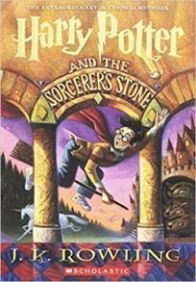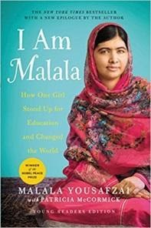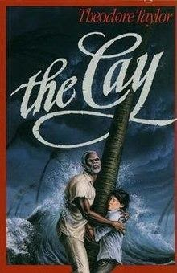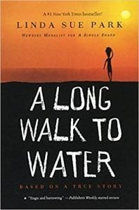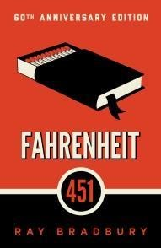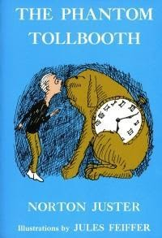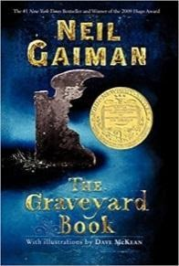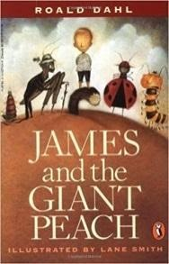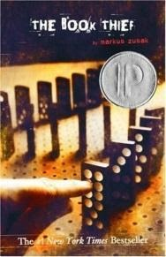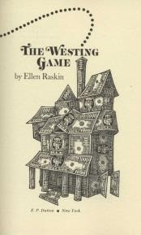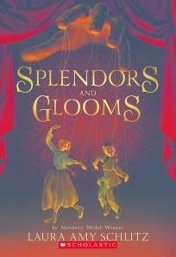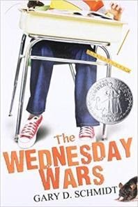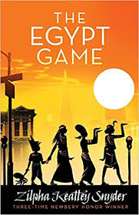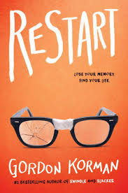

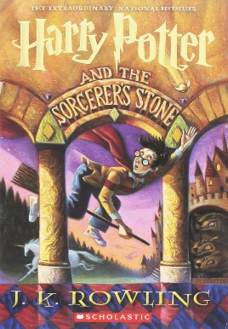
Name_____________________________________________Date__________________
Summer Reading Assignment - Grade 7
Mandatory Assignment 1 - Read Harry Potter and the Sorcerer’s Stone by J.K. Rowling and complete this packet. It will be collected the first week of school. Read through the packet BEFORE you begin reading the book.
Optional Assignment 2 – Reading Challenge - Read a second, third, fourth... novel from the recommended list or one of your choosing. It should be a novel you have never read before and be appropriate in content and reading level. Record the titles and authors of the books you read and bring it to school in September.

Directions:
- Answer all of the following questions.
- Write in complete sentences where you see an asterisk (*).
- Spelling, capitalization, punctuation, and neatness are important.
- You may want to answer some of these questions while you are reading your book.
- You may type or handwrite this assignment. A link to this assignment will be on my website.

Introduction/General Information about the Book

Title of Book ___________________________________________________________________

Author ________________________________________________________________________

Genre (fantasy, humor, science fiction, mystery, realistic fiction, historical fiction)

________________________________________________________________________

Characters
Main Character: __________________________________________________________

*Describe this character: ___________________________________________________

________________________________________________________________________

________________________________________________________________________

________________________________________________________________________

________________________________________________________________________

*I can identify with the main character when (Write about how the character may be similar to you, someone you know, or any of your experiences?)___________________

________________________________________________________________________

________________________________________________________________________

Another Character: ________________________________________________________

*Describe this character: ___________________________________________________

________________________________________________________________________

________________________________________________________________________

________________________________________________________________________

Another Character: ________________________________________________________

*Describe this character: ___________________________________________________

________________________________________________________________________

________________________________________________________________________

________________________________________________________________________

Setting
*Describe the time and place of the story. _____________________________________

________________________________________________________________________

________________________________________________________________________

________________________________________________________________________

Theme
*This book showed me/I learned from this story...

________________________________________________________________________

________________________________________________________________________

________________________________________________________________________

________________________________________________________________________

*State a problem in the story and how it was solved. ______________________________

________________________________________________________________________

________________________________________________________________________

________________________________________________________________________

________________________________________________________________________

Plot: The Action/Summary of What Happened in the Story
*Summary of the story. List, in order, six important events that happened in the story that affect the plot.

1. ______________________________________________________________________

________________________________________________________________________

________________________________________________________________________

2. ______________________________________________________________________

________________________________________________________________________

________________________________________________________________________

________________________________________________________________________

3. ______________________________________________________________________

________________________________________________________________________

________________________________________________________________________

________________________________________________________________________

4. ______________________________________________________________________

________________________________________________________________________

________________________________________________________________________

________________________________________________________________________

5. ______________________________________________________________________

________________________________________________________________________

________________________________________________________________________

________________________________________________________________________

6. ______________________________________________________________________

________________________________________________________________________

________________________________________________________________________
Evaluation of the Book

*What did you like about the book? Explain. ___________________________________

________________________________________________________________________

________________________________________________________________________

*What did you dislike about the book? Explain. ________________________________

________________________________________________________________________

________________________________________________________________________

*The ending was… (Describe the ending and your reaction.)_______________________

________________________________________________________________________

________________________________________________________________________

________________________________________________________________________

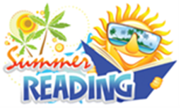
Summer Reading Log
AFTER you finish each book, log it here to keep track of your accomplishments!

Genre | Book Title | Author Name | Rating
Fantasy | Harry Potter and the Sorcerer’s Stone | J.K. Rowling
*You can continue your list on the back if necessary. That would be amazing.

Self-Assessment: How have you grown, improved, or changed as a reader this summer? Explain with specifics.

